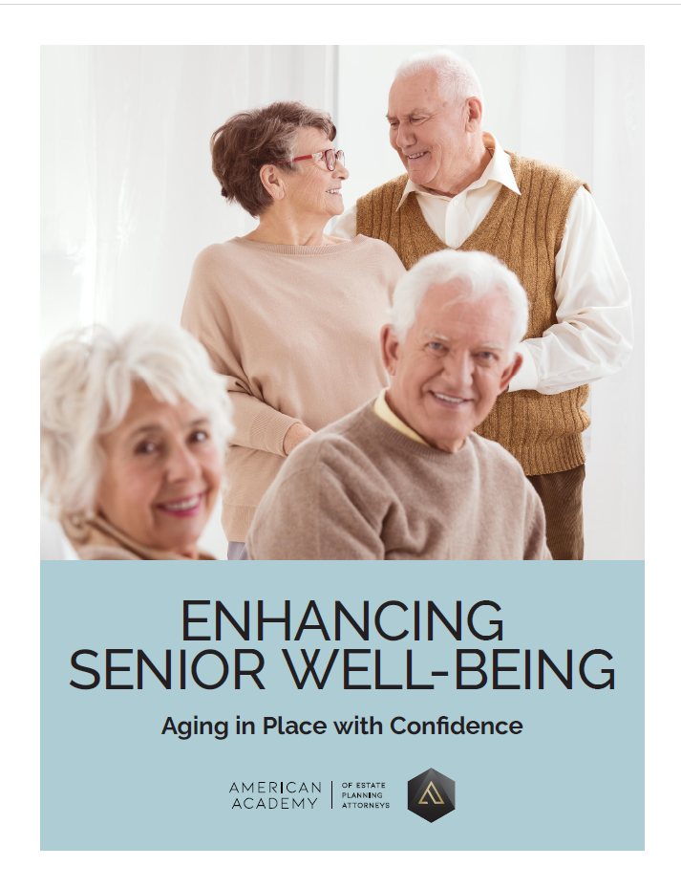

about the firm

The Potter Law Firm is dedicated to providing you with quality estate planning resources, so you can become familiar with all of the existing options. When you visit or call our office, we want you to feel comfortable discussing such an important issue concerning both you and your family. We want to arm you with the information you need to make an informed decision about your family’s future.
If you have a well-drafted estate plan in place, you’ll ensure that your estate passes to whom you want, when you want, and is carried out in the manner you’ve chosen. You can rest assured that your family won’t have to endure the public process and costly matter of probate. The government won’t be able to take what you’ve spent a lifetime building. But you need to be aware of the many options that exist in estate planning—and you must choose your attorney wisely.
In these turbulent times, if you or your loved ones would like a complimentary consultation to discuss your estate plan and financial strategy, visit our website at www.potterestateplanning.com, or call us today at 704-944-3245 to schedule an appointment.

Follow us online
 | facebook.com/thepotterlawfirm |  | instagram.com/jpotternc
 | twitter.com/#!/potterlawfirm |  | youtube.com/user/PotterLawKY
 | linkedin.com/pub/john-potter/10/510/947

Enhancing Senior Well-Being: Aging in Place with Confidence
In the tapestry of human existence, connections serve as the vibrant threads that weave together our lives. For senior citizens, these connections are not just a matter of companionship; they are lifelines to vitality, health, and well-being.
Social connection is the intricate web of relationships, interactions, and sense of belonging that individuals experience within their communities and society at large. It encompasses the richness of human connection, extending beyond mere acquaintance to include the depth and quality of relationships. Social connection is not solely determined by the quantity of relationships but also by the diversity, frequency, and reliability of interactions. At its core, social connection provides individuals with a sense of belonging, support, and mutual understanding, contributing to their emotional well-being and overall quality of life. It encompasses both the structural aspects, such as the number and variety of relationships, and the functional aspects, including the degree to which individuals can rely on others for support. Ultimately, social connection serves as a vital lifeline, enriching our lives and fostering a sense of community and belongingness.
In this report, we delve into the profound importance of connections to senior citizens, recognizing their pivotal role in combating isolation, loneliness, and other challenges associated with aging. We explore the vital link between meaningful relationships and social connections and their impact on independence and aging in place. Additionally, we provide practical suggestions and activities to foster these connections, promoting a fulfilling and enriched senior experience.
Health and Well-Being
Numerous studies have highlighted the significant impact of social connections on the health and well-being of senior citizens. Social isolation increases the risk of premature death by 29%. Furthermore, it is associated with an increased risk for anxiety, depression, and dementia, along with a myriad of adverse health outcomes, including cardiovascular problems, compromised immune function, and increased mortality rates.
Strong social ties have been linked to reduced risk of chronic diseases, lower levels of stress and depression, and improved cognitive function.
Mental Health
Social isolation can significantly impact the mental health of senior citizens, presenting a formidable challenge that can erode well-being and diminish quality of life. For many older adults, the absence of regular social interactions and meaningful connections can breed feelings of loneliness, helplessness, and despair. The sense of detachment from the world around them can exacerbate existing mental health conditions, such as depression and anxiety, while also increasing the risk of developing new ones.
Without the buoying effect of social support networks, seniors may find themselves trapped in a cycle of negative thoughts and emotions, which can further isolate them from seeking the assistance they need. Moreover, prolonged periods of social isolation can contribute to cognitive decline, exacerbating feelings of loneliness and diminishing overall mental resilience. In essence, the impact of social isolation on the mental health of senior citizens is profound and multifaceted, highlighting the urgent need for interventions and support systems that prioritize connection and community engagement.
Cognitive Function
Social engagement plays a crucial role in preserving cognitive function and staving off cognitive decline in older adults. Research suggests that seniors who lack regular social interactions and engagement may experience accelerated cognitive decline compared to their socially connected counterparts. The absence of stimulating conversations, intellectual pursuits, and social activities deprives the brain of essential cognitive stimulation, leading to diminished cognitive reserves over time.
Moreover, social isolation often correlates with a sedentary lifestyle, which further compounds the risk of cognitive impairment. Without opportunities for mental stimulation and social engagement, seniors may experience difficulties with memory, attention, and executive function. Consequently, addressing social isolation among older adults is paramount not only for their emotional well-being but also for preserving cognitive function and promoting healthy brain aging.
Emotional Support
Emotional support is a cornerstone of well-being for senior citizens, offering solace, validation, and resilience in the face of life's challenges. As individuals navigate the transitions and uncertainties that accompany aging, having a network of emotional support becomes increasingly crucial.
For many seniors, emotional support comes from close relationships with family members, friends, or caregivers who provide empathy, understanding, and companionship. These supportive relationships offer a safe space for expressing feelings, processing grief or loss, and seeking guidance during times of adversity.
Emotional support bolsters seniors' sense of self-worth and belonging, affirming their value as individuals with experiences, wisdom, and stories to share. Moreover, knowing that they have someone to turn to in times of need fosters a sense of security and confidence, enabling seniors to navigate the ups and downs of life with greater resilience and grace.

Supporting Independence and Aging in Place
As individuals grow older, the desire to maintain independence and continue living in familiar surroundings becomes increasingly paramount. However, achieving this goal is often challenged by various factors, including declining health, mobility limitations, and social isolation.
In this section, we explore strategies and initiatives aimed at supporting seniors in their quest to age in place with dignity and autonomy. By addressing the barriers to independence and fostering a supportive environment within communities, we endeavor to empower older adults to remain active participants in their lives while staying connected to the people and resources that matter most to them.
Combatting Isolation and Loneliness
One of the most significant barriers to aging in place is the risk of social isolation and loneliness. By fostering connections within the community, seniors can maintain their independence and quality of life. Community-based programs, senior centers, and volunteer opportunities offer avenues for social interaction and engagement. Technology can also play a role in connecting seniors with loved ones and accessing virtual social networks.
Supportive Services
Access to supportive services is essential for seniors to age in place successfully. By establishing strong connections with local service providers such as the type listed below, seniors can access the support they need to remain independent while staying connected to their community.
- Transportation assistance: Accessible transportation services to help seniors attend medical appointments, grocery shopping, and social activities.
- Home care services: Assistance with activities of daily living such as bathing, dressing, meal preparation, and medication management.
- Health resources: Access to healthcare providers, home health aides, and medical equipment to support seniors' physical and mental well-being.
- Financial assistance: Guidance on managing finances, accessing benefits such as Social Security and Medicare, and navigating healthcare costs.
- Home modifications: Adaptations to the home environment to improve safety and accessibility, including grab bars, ramps, and stairlifts.
- Legal assistance: Support with estate planning, advanced directives, and legal matters related to housing, healthcare, and finances.
- Social services: Referrals to community-based programs, support groups, and counseling services to address social isolation, mental health concerns, and emotional needs.
- Care coordination: Coordination of services and resources to ensure seniors receive comprehensive and integrated care tailored to their individual needs.

Fostering Connections: Suggestions and Activities
For many senior citizens, the specter of social isolation looms large, casting a shadow over their well-being and sense of belonging. However, it's never too late to break free from the bonds of isolation and embrace a life filled with meaningful connections and enriching experiences. Suggested strategies and activities that senior citizens can adopt to combat social isolation and cultivate vibrant social networks include:
- Join a Senior Center or Club: Senior centers offer a plethora of activities and programs designed to foster social interaction and engagement. From fitness classes and hobby groups to educational workshops and social events, these centers provide opportunities for seniors to connect with peers who share similar interests.
- Volunteer in the Community: Volunteering not only benefits the community but also provides seniors with a sense of purpose and fulfillment. Whether it's serving meals at a local soup kitchen, tutoring children at a school, or participating in environmental clean-up efforts, volunteering offers opportunities for social interaction while making a positive impact on the lives of others.
- Attend Social Events and Gatherings: Keep an eye out for social events and gatherings in your community, such as potluck dinners, movie nights, or cultural festivals. These events provide opportunities to meet new people, forge friendships, and participate in shared experiences that bring joy and camaraderie.
- Join a Fitness Class or Walking Group: Physical activity not only benefits your physical health but also your social well-being. Joining a fitness class or walking group not only provides opportunities for exercise but also fosters social connections with fellow participants. Whether it's yoga, tai chi, or a group walk in the park, staying active together can strengthen bonds and lift spirits.
- Embrace Technology for Social Connection: Technology offers a wealth of opportunities for seniors to stay connected with loved ones and engage in virtual social interactions. Learn how to use video calling apps to connect with family and friends, join online forums or social media groups based on your interests, and explore virtual events and activities tailored for seniors.
- Participate in Intergenerational Programs: Engage with younger generations through intergenerational programs that bring seniors and youth together for shared activities and learning experiences. Whether it's reading to children at a local library, mentoring a young adult, or participating in school-based initiatives, intergenerational interactions offer mutual benefits and meaningful connections across generations.
- Reach Out to Loved Ones: Don't hesitate to reach out to family members, friends, and neighbors to maintain and nurture your existing relationships. Schedule regular phone calls, video chats, or in-person visits to stay connected and share stories, laughter, and support.
By embracing these activities and strategies, senior citizens can take proactive steps to combat social isolation, nurture meaningful connections, and enrich their lives with the warmth of community and companionship. Remember, you're never alone on this journey, and there's a world of opportunities waiting for you to explore and embrace.

About the academy

This report reflects the opinion of the American Academy of Estate Planning Attorneys. It is based on our understanding of national trends and procedures and is intended only as a simple overview of the basic estate planning issues. We recommend you do not base your own estate planning on the contents of this Academy Report alone. Review your estate planning goals with a qualified estate planning attorney.
The Academy is a national organization dedicated to promoting excellence in estate planning by providing its exclusive Membership of attorneys with up-to-date research on estate and tax planning, educational materials, and other important resources to empower them to provide superior estate planning services.
The Academy expects Members to have at least 36 hours of legal education each year specifically in estate, tax, probate and/or elder law subjects. To ensure this goal is met, the Academy provides over 40 hours of continuing legal education each year. The Academy has also been recognized as a consumer legal source by Money Magazine, Consumer Reports Money Adviser and Suze Orman in her book, 9 Steps to Financial Freedom.

Additional Reports
Interested in additional reports? Visit our website at https://potterestateplanning.com or simply call our office at (704) 944-3245.

Holt-Lunstad J, Smith TB, Baker M, Harris T, Stephenson D. Loneliness and social isolation as risk factors for mortality: a metanalytic review. Perspect Psychol Sci. 2015;10(2):227-237.
0. Penninkilampi R, Casey AN, Singh MF, Brodaty H. The Association between Social Engagement, Loneliness, and Risk of Dementia: A Systematic Review and Meta-Analysis. J Alzheimer’s Dis. 2018;66(4):1619-1633.

